Mr SGs Materials and Bonding Notes

Classification of Materials
-Chemistry is the study of matter (anything that occupies space and has mass)

-Matter (materials) can be classified based on its properties and the arrangement of particles within the substance

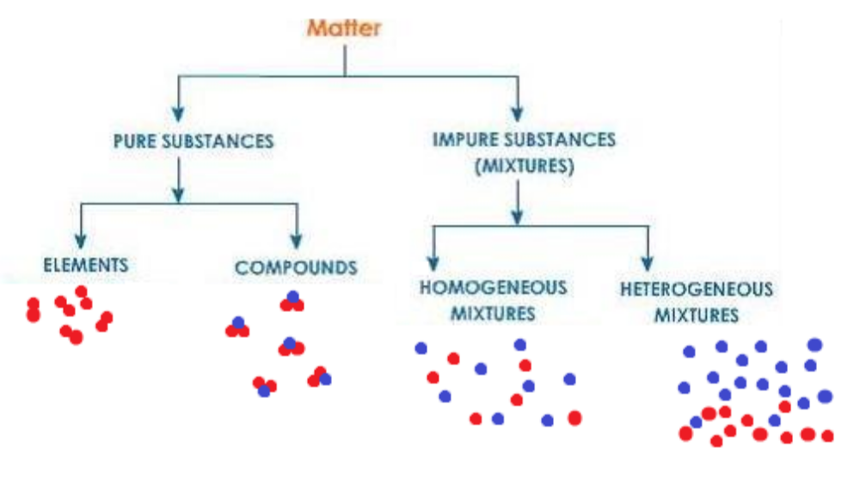
Matter: -Anything that has mass and takes up space

Pure substances: -Contains only one type of particle
-Cannot be separated by physical means (based on physical properties)

Mixtures: -Contain more than one type of particle
-Can be separated by physical means (based on physical properties)

Elements: Contains only one type of atom (e.g. hydrogen)

Compounds: Contain 2 or more elements, chemically combined in a fixed ratio (e.g. pure water)

Homogenous Mixtures (solutions): uniform composition (e.g. salt water, brass, air)

Heterogenous Mixtures: non-uniform composition (e.g. sand in water)

Physical and Chemical Properties

-Materials can be either pure substances or mixtures

-All pure substances have distinct physical and chemical properties, but the properties of a mixture depend on the identity and relative amounts of its components

-Chemical properties are the chemical reactions a substance can undergo

-They only be observed by changing the identity of a substance (e.g. the reactivity of Na metal in water, can only be observed by adding it to water, thus changing the substance into a solution of sodium hydroxide)

-Physical properties are those that can be observed without changing the identity of the substance (e.g. the boiling point of water can be observed without changing the identity of the water molecules)

-The components of a mixture can be separated based on their physical properties

Physical Properties

Melting /Boiling point: -The temperature at which a solid melts/ liquid boils
-Dependent on the strength of interparticle forces (not intraparticle bonds)

Density (ρ): -A measure of how tightly packed matter is within a substance
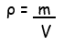

Hardness: -A measure of how resistant a substance is to deformation
-Dependant on the strength/type of forces holding a substance together

Solubility: -How much of a substance will dissolve in a given solvent at a given temperature
-Dependent on the relative strength of solute-solute and solute-solvent forces
-Generally, higher when solvent & solute have similar polarity

Colour: -A measure of the wavelengths of light that a substance can absorb and reflect
-Related to electron arrangement

Electrical conductivity: -How well a substance can conduct an electrical current
-A measure of the number of free moving charged particles in a substance

Thermal conductivity: -How well a substance can conduct heat
-Related to how tightly packed particles are in a substance
-Increased by the presence of delocalised electrons

Particle size: The size of the particles in a substance (not necessarily the size of the atoms)
Separation Techniques

-In Chemistry, we often need to separate a mixture of chemicals

-Components of a mixture are separated, based on their physical properties, as separation based on their chemical properties would involve chemical reactions that would change the identity of the substances

Filtration (includes sieving)
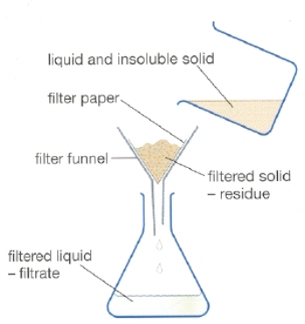
-Separates based on difference in particle size

-Typically used to separate an insoluble solid from a liquid or a solution (e.g. sand from water)

-Sieving used to separate solids with different particle sizes

Evaporation
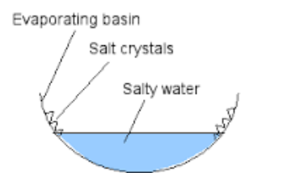
-Separates substances based on differences in volatility (how readily they will evaporate)

-Often used to obtain solute from solution (e.g. copper sulfate from copper sulfate solution)

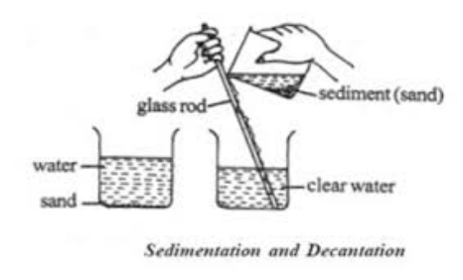
Gravity Separation/Decantation
-Separation based on differences in density

-Typically used to separate insoluble solid from liquid or to separate solids with different densities (e.g. separating gold from quartz)

Simple distillation
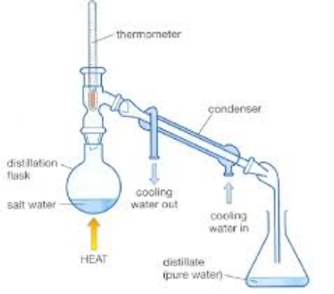
-Separates based on differences in boiling point

-Typically used to obtain solvent from solution (e.g. water from sodium chloride solution)

Fractional distillation
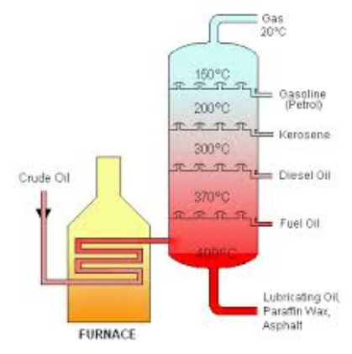
-Separates based on differences in boiling point

-Typically used to obtain liquid with lower boiling point from a mixture of different liquids (e.g. separating different hydrocarbons from crude oil)

Chromatography
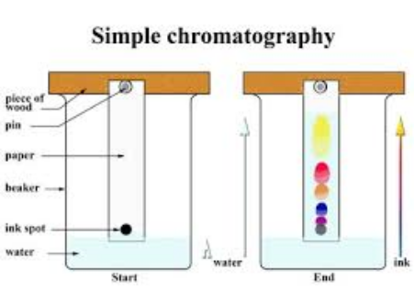
-There are a number of different forms of chromatography

-All involve passing a mixture over an inert substance

-Separation based on solubility of substances in mixture versus tendency to bind to the inert substance (e.g. based on the intermolecular forces of the substances)

-Substances that tend to stay dissolved in the liquid (mobile phase) are separated from those that tend to bind to the inert substance (stationary phase)

Nanomaterials

-Materials can be classified based on their properties and the composition of their particles

-They can also be classified based on the size of their particles

-Nanomaterials are a type of materials that have particles that are larger than individual atoms, but smaller than the particles of other bulk materials

-Nanomaterials are defined as those that have particles between 1-100 nm (1 x 10⁻⁹ m) in scale

-Many nanomaterials have properties that differ from those of the bulk material due to quantum (size dependent) effects

Colloidal Gold
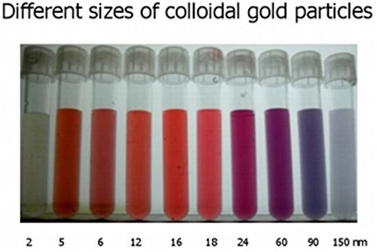
-As a bulk material, gold has a yellow colour and a characteristic metallic lustre

-Colloidal gold (a colloid is intermediate between a solution and a suspension) contains gold nanoparticles

-As nanoparticles, the colour displayed by gold depends on the size of the particles present (optical properties often display quantum effects)

Nanoparticles in Suncreens (ZnO/TiO)
-ZnO and TiO offer excellent UV protection as bulk materials, but produce an opaque white layer on the skin

-As nanoparticles, they offer the same UV protection, but are invisible (another example of an optical quantum effect)

Fullerenes
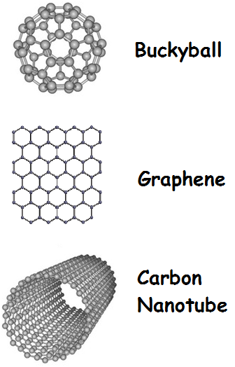
-Fullerenes are a class of naturally occurring nanomaterial made from networks of carbon atoms, including buckyballs, graphene and carbon nanotubes

-Graphene is a material that consists of flat sheets of carbon, where each atom is bonded to 3 other carbon atoms in a hexagonal structure

-Carbon nanotubes have a structure similar to a graphene sheet rolled into a thin tube

-Carbon nanotubes have an extremely high strength and stiffness making them useful in composite materials

-Their electrical conductivity can be varied by altering the dimensions of the tube (they can be conductors or semiconductors), making them useful in electronic applications
Bonding

-All materials all held together by the electrostatic forces of attraction between opposite charges with the material

-These forces of attraction are known as bonds or bonding forces

-The charged particles that experience the bonding result from the way that atoms delocalise, lose, share or gain electrons to attain a noble gas electron configuration

-The type of bonding in a material is also determined by the elements present (e.g. metals/semi-metals/non-metals)

-The bonding forces also determine the properties of materials

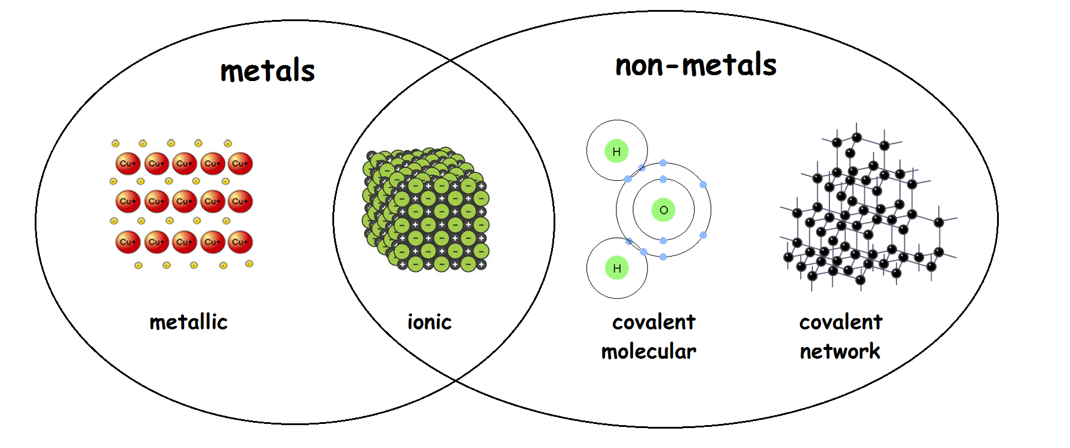

Metallic Bonding

-Metallic elements have valence shells that are less than half full, meaning that it is easier for them to attain a full outer shell by losing electrons than by gaining them

-In metallic elements, metal atoms delocalise their valence electrons, forming metal cations, which are arranged in a regular lattice

-The delocalised electrons form a “sea of electrons” that move through the lattice

-The metallic bond is the electrostatic force of attraction between the metal cations and the delocalised electrons

-It is this force that holds metals together and produces their physical properties

Physical properties of metals

Property | Explanation
Malleability & Ductility | Rows of cations can slide over one another without disrupting the non-directional metallic bonds
High MP/BP | It takes a lot of energy to overcome the strong metallic bonds that hold the particles in their solid/liquid arrangement
High thermal conductivity | Close packing of metal cations mean that E_{k} can be readily transferred from one cation to the next as vibrations. Delocalised electrons can also move through the lattice carrying E_{k} from one location to another
High electrical conductivity | Delocalised electrons can move through the lattice carrying a charge
Opacity & density | Cations are very tightly packed, resulting in a high density and an inability for light to penetrate the material
Lustre | Regular arrangement of cations at surface results in a very smooth, reflective surface

-While these properties are characteristic of metals, they do vary depending on periodic table position

-Group 1 metals only delocalise one electron per atom and are loosely packed, resulting in a lower density and lower melting and boiling points.

Alloys

-While there are no metallic compounds, it is possible to form a homogenous mixture (solution) of two or more mixtures
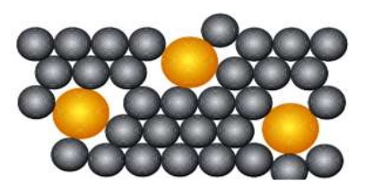

-Alloys are prepared to modify the properties of the parent metal, in order to make it more suitable for a particular purpose

-They are often harder than pure metals, as the addition of different sized atoms can make it harder for layers to slide over one another

Alloy | Composition | Properties
Steels | Fe/C +/- Ni,Cr | High strength & hardness. Rust resistant when Ni/Cr added
Solder | Pb/Sn | Lower melting point than either Pb or Sn
9-carat gold | Au/Ag | Harder and more durable than pure gold

Names and Formulae

-As there are no metallic compounds, the naming rules and formulae for metallic substances are very simple

-They are given the name and symbol of the element as shown in the periodic table
Ionic Bonding

-Ion: An atom or group of atoms that has lost or gained electrons to become electrically charged

-Ionic compound: compound composed of positive (generally metal) and negative (generally non- metal) ions

-Ionic bond: The electrostatic attraction between positive ions (cations) and negative ions (anions) in an ionic compound

How ionic compounds form (e.g. sodium chloride)
-Sodium needs to lose one valence electron to have a full outer shell, while chlorine needs to gain one valence electron to have a full outer shell

-Sodium donates its valence electron to chlorine, forming the Na⁺ ion and the Cl⁻ ion

-The oppositely charged ions are attracted to each other and form an ionic compound

-Some atoms can donate or accept more than one electron to form ions such as Ca²⁺, N³⁻ etc

-Ions will always combine in a set ratio, so that the charges cancel out (e.g. Cu²⁺ and S²⁻ form CuS, Fe³⁺ and O²⁻ form Fe₂O₃)

-Some ionic compounds are formed with polyatomic ions (ions containing more than one atom), e.g. CuCO₃ contains the Cu²⁺ ion and the CO₃²⁻ ion
(NH₄)₂CO₃ contains the NH₄⁺ ion and the CO₃²⁻ ion

Structure of ionic compounds
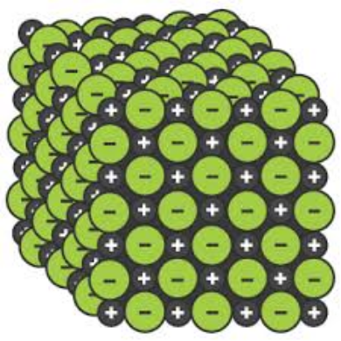
-In ionic solids, ions with like charges repel and ions with opposite charges attract, causing the ions to arrange themselves in an ‘ionic lattice’ where each anion is surrounded by cations (and vice versa)

-In the liquid state, ions are no longer in a fixed position and move past one another, but the ionic bond is still present

-In the aqueous state, the ionic lattice fully separates and individual ions become surrounded by water molecules
Physical properties of ionic compounds

Property | Explanation
High MP/ BP | It takes a lot of energy to overcome the strong ionic bonds that hold the particles in the ionic lattice
Brittle | When one row of ions slides over another, like charges align and repel, causing ionic lattice to shatter
Non electrical conductors as solids | Charged ions immobilised in fixed positions in ionic lattice
Good electrical conductors in liquid/aqueous state | Charged ions are free to move, carrying a current
Non-soluble in non-polar solvents | Strong ionic bonding forces within the lattice are not able to be overcome by weak forces of attraction to non-polar molecules
Can be coloured or colourless | Transition metal ions are generally coloured, while Group 1-2 metal ions and most anions are colourless

Names of ionic compounds
-Metal ions keep the name of the element e.g. Fe²⁺ is iron, Cu²⁺ is copper

-Monoatomic non-metal ions (ions with only one atom) are given the name of their element with the end of the name changed to -ide e.g. Cl⁻ is chloride, O²⁻ is oxide

-The name of an ionic compound, is the name of the ions present, with the cation listed first e.g. NaF is sodium fluoride, MgCl₂ is magnesium chloride

Formula of Ionic compounds
-The formula of an ionic compound shows the simplest ratio of the ions present

-If a more than 1 unit of a polyatomic ion is present in the formula, it needs to be shown in brackets when indicating the number of ions present e.g. Cu(NO₃)₂

Representing ionic compounds with electron dot diagrams (Lewis Structures)
-Electron dot diagrams are a method for showing the electron structure of an atom or an ion

-For atoms, the symbol of the atom is shown, with the number of valence electrons shown as dots
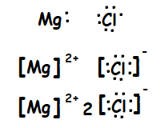

-For ions, the structure is shown in a square bracket, with the charge shown to the top right

-For ionic compounds, the relative number of each ion is shown in front of the ion
Covalent Molecular Bonding

-Covalent molecular compound: A compound comprised of non-metal atoms that share electrons in discrete molecules

-Covalent bond: The electrostatic attraction between shared electrons and positive nuclei

How covalent bonding works (e.g. chlorine gas)
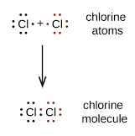
-Two chlorine atoms each need to gain one valence electron to have a full outer shell

-Each atom shares one of its valence electrons with the other chlorine atom, so that each atom has access to 8 valence electrons (6 of its own and the 2 shared electrons)

Multiple covalent bonds
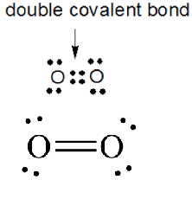
-Two oxygen atoms each need to gain 2 valence electrons to have a full outer shell

-Each atom shares 2 of its valence electrons with the other oxygen atom, so that each atom has access to 8 valence electrons (4 of its own and the 4 shared electrons)

-This is known as a double covalent bond. Triple covalent bonds (containing 6 shared electrons) are also possible

Intermolecular Forces (van der Waals forces)
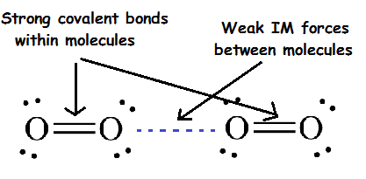
-While the covalent bond itself is a strong bond, the intermolecular forces between adjacent molecules are very weak

-Forces between molecules are due to the interactions of small (often temporary) charges on adjacent molecules

-The strength and type of intermolecular forces determine the physical properties of covalent molecular substances, as these are the forces that need to be overcome to alter the physical arrangement of molecules without changing their identity

-We will study these forces in detail in Semester 2

Properties of covalent molecular substances
Property | Explanation
Low MP/BP | Little energy is required to overcome the weak IM forces holding adjacent molecules together
Non-conductors of electricity as solids and liquids | Covalent molecular compounds do not contain mobile charge carriers
Variable electrical conductivity in aqueous state | Some covalent compounds ionise in solution, producing mobile charge carriers (e.g. HCl_{(g)} → H⁺_{(aq)} + Cl⁻_{(aq)})
Soft as solids | Adjacent molecules can easily slide past one another due to weak IM forces
Most solids are malleable | Molecules can easily slide past one another without completely breaking the weak non-directional IM forces
Generally have low solubility in water and higher solubility in non-polar solvents | Solutes tend to have higher solubilities in solvents that experience similar IM forces (“like dissolves like”)
Many have a detectable odour | Weak IM forces make it easier for particles to become airborne

Names and Formulae of Covalent Molecular Substances
Formula: The number and type of atoms in a molecule. This is true for both elements and
compounds (e.g. O₂, CO₂, N₂O₅ etc)

Name (elements): Elements are given their name from the periodic table (e.g. O₂ is oxygen)

Name (compounds): (example given for N₂O₅)
-Write the name of the element closer to the bottom
left of the periodic table first nitrogen

-Write the name of the other element second, with the
end of the name changed to -ide nitrogen oxide

-Use prefixes to denote the number of atoms of each
element in the molecule (mono=1, di=2, tri=3, tetra=4,
penta=5, hexa=6). Only use mono for the 2nd element dinitrogen pentoxide

Lewis Structures: covalent molecular substances and polyatomic ions

-Electron dot diagrams for covalent molecular substances can be sketched using the NHB (Need/Have/Bonds) method

Method Example (CO₃²⁻)

1) Write the symbols of the atoms in the compound.
If a central atom is needed it is never H, rarely O O C O
and it is generally the atom to the furthest left
on the periodic table O

2) N(eed). Calculate the total number of electrons N = 4 x 8 = 32
needed for each atom to have a full valence shell.
This is 2 for hydrogen and 8 for most other atoms

3) H(ave). Calculate the number of valence electrons H = 4 + 3 x 6 – (-2) = 24
present. This is the sum of the valence electrons of
the atoms present (minus the charge for ions)

4) B(onds). As bonding electrons are used by two B = (N-H)/2
atoms, each bond uses two electrons, but reduces the = (32 – 24)/2
number of electrons needed by four. Calculate the = 4
number of bonds in the molecule using B = (N-H)/2
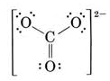
5) Draw the bonds in the structure and add the
remaining electrons as lone pairs. Add square brackets
for polyatomic ions
Covalent Network Bonding
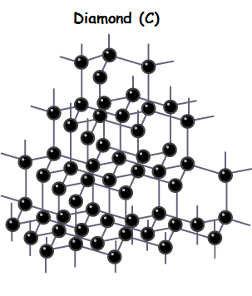
-Covalent network compound: A compound comprised of non-metal atoms covalently bonded in a network lattice

Covalent network bonding
-Many metalloid elements and elements near the metalloids in the periodic table can form covalent network substances, including C, Si, B, P, Ge, As, Se, Sb and Te
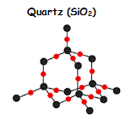
-This is because elements need to be able to form a minimum of 3 covalent bonds to other atoms to form the lattice structure

-Compounds such as SiO₂ also exhibit this type of bonding

-Covalent network substances tend to be chemically inert

-The physical properties of covalent network solids are distinct from those of covalent molecular substances because the overall structure of the material is held together by strong covalent bonds, rather than weak intermolecular forces

Physical properties of covalent network substances
Property | Explanation
Very high MP and BP | Entire lattice is held together by strong covalent bonds
Non-conductors of electricity in all states (except graphite) | No mobile charge carriers in lattice
Extremely hard | All atoms are held in rigid lattice by strong covalent bonds
Brittle | Bonds holding lattice together are directional and must be broken to displace atoms
Insoluble in polar and non-polar solvents | Dissolving requires breaking of strong covalent bonds

Names and Formulae of Covalent Network Substances
Formula (elements): The element’s symbol from the periodic table

Formula (compounds): The elements present with subscript numbers to denote their ratio (e.g. SiO₂ has 2 oxygen atoms for each silicon atom

Name (elements): The element’s name from the periodic table

Name (compounds): Compounds are named as per covalent molecular compounds, but the prefixes refer to the ratio of elements in the compound, rather than the number of atoms per element
Allotropes of Carbon

-Allotropes are different forms of elements, containing the same atoms but in a different bonding arrangement

-Carbon has three main allotropes, diamond, graphite and amorphous carbon

Diamond

-In diamond, each carbon atom is bonded to four others, with the bonds angled at 109.5º from each other
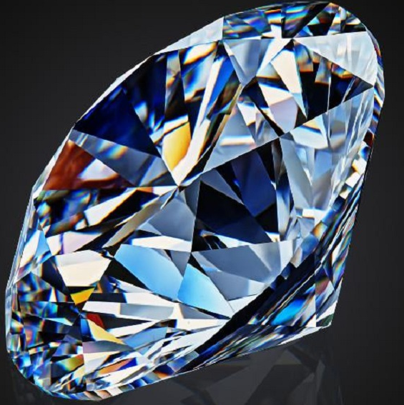

-This makes it incredibly hard and brittle due to the 3D network of covalent bonds

-It also prevents it from melting (it sublimes at ~3500ºC)

-As well as its uses in jewellery, diamonds hardness makes it useful for drill bits and cutting tools

Graphite
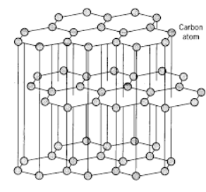
-In graphite, each carbon atom is bonded to three others, with the bonds angled at 120º from each other in flat sheets which are stacked in layers

-The final valence electron from each atom is delocalised and can move between layers

-While each layer is held together by strong covalent bonds, adjacent layers are held together by weak IM forces

-Graphite is soft and slippery because adjacent layers can slide past one another, which allows it to be used as a dry lubricant and in pencils

-It conducts electricity because the delocalised electrons act as mobile charge carriers, which allows it to be used in electrodes in batteries and electrolytic cells

-Fullerenes such as graphene and carbon nanotubes have a structure similar to a single sheet of graphite

Amorphous carbon
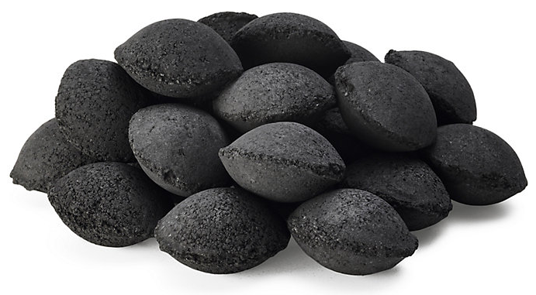
-Amorphous carbon does not have a consistent internal structure

-While the bonding of each atom is akin to carbon, the sizes of the graphite crystals are very small and the separation between them is very large

-Charcoal is composed of amorphous carbon

-As well as being used as fuel, amorphous carbons highly porous structure makes it useful in filters

Summary of bonding, structure and properties

